
SC2002
Object-Oriented Design & Programming Assignment
Internship Management System
Lab Group: SBAC1
Group Number: 3
Group Members:
S/N | Full Name | Matric. Number
1 | Isaac Lim Yu Heng | U2410807F
2 | Jonah Choke Ming Kai | U2410758A
3 | Kylie Pang Kai Li | U2410181K
4 | Maureen Kai Shu Yuan | U2410322G
5 | Shaikh Aliyy Uraidhy Bin Shaikh Mohamed Reza Mattar | U2410897K
GitHub Link: https://github.com/kylie-pang/SC2002-SBAC1-Group_3
1) Introduction
Understanding Problem & Requirements
At the start of the assignment, we broke down the overall internship management workflow and identified the core needs of the three user groups: Students, Company Representatives, and Career Center Staff. Each role required authentication, its own menu, and specific actions within the system.

Explicit Requirement Identified
- User authentication, including handling of default passwords.
- Role-specific functionality:
  - Students: view opportunities, apply/withdraw, view application status and confirm internship
  - Company Representatives: create/edit/delete postings, approve/reject applications
  - Career Center Staff: approve company reps and postings, manage withdrawal requests, generate internship reports
- Internship opportunity process: Creation → Pending approval → Approval/Rejection → Visibility to students
- Application process: Submission → Pending → Successful/Unsuccessful → Confirmed/Withdrawn
- Limits and validation:
  - Student can have a maximum of 3 active pending applications
  - Company Reps can post a maximum of 5 active opportunities
Implicit Requirement Identified
- Automatic withdrawal of other applications after student confirms an internship
- Application cannot be processed by rep after withdrawal
- Filtering logic based on student major and internship level
- Slots should decrement only upon confirmation (not application)
By conducting this structured analysis, we were able to define the system’s scope and guide our early design choices. Through discussions and logical assumptions, we addressed these uncertainties and established a solid foundation for our design approach.

2) Design Approach
Overall System Architecture
The internship management system was designed with the following in mind: low coupling, high cohesion and ease of change over time. Instead of treating it as an implementation task, we consciously mapped the requirements to an OO model with clear responsibilities, separation of concerns and support for future extensibility.
The system follows a simple Entity-Boundary-Controller style structure adapted to a console application:
Layer | Classes | Responsibilities
Entity | - User and its subclasses  - InternshipOpportunity  - InternshipApplication  - Application Status  - OpportunityStatus  InternshipLevel | Holds business concepts and rules such as application limits, eligibility, and status transitions.  Examples from our code:  - Student.applyForInternship() contains rules like:  - Major must match  - Level eligibility  - Maximum 3 pending applications  - CompanyRepresentative.createInternship() enforces:  - Maximum 5 opportunities  Account must be approved
Boundary | - System Controller  Student.displayMenu()  CompanyRepresentative.displayMenu()CareerCenterStaff.displayMenu() | Our program uses the console rather than a GUI but the methods used allows to  - show the interface to the user  - display lists of opportunities  - show application results and statuses  ask for user input
Controller | System Controller | Orchestrates user flows and coordinates interactions
Data Access Layer | CsvReader  FileHandler  StudentLoader  StaffLoader  CompanyRepLoader | Helps with reading CSV input and constructing domain objects. They shield the rest of the system from file I/O and CSV parsing details

3) Application of OOD Principles & OOP Concepts
3.1 Overview of the System Design
The Internship Management System was designed using Object-Oriented Design (OOD) principles to ensure modularity, maintainability, and extensibility.
The application supports three different user roles:
• Students
• Career Center Staff
• Company Representatives
All major workflows—such as internship browsing, application, approval, and filtering—were implemented with clean separation of responsibilities and strong object-oriented abstractions.
The final design avoids the “God class” anti-pattern and instead distributes logic across multiple cohesive and reusable components.
3.2 Applying Object-Oriented Design (OOD) Principles
Our design follows the main SOLID principles to keep the system clean and easy to maintain.
Single Responsibility Principle (SRP) | Each class has one clear responsibility and one reason to change.  - StudentController – Manages student workflows (view, apply, withdraw, confirm offers).  - StaffController – Manages Career Centre workflows (approve reps, internships, withdrawals, reports).  - CompanyRepController – Handles company rep workflows (create/edit opportunities, view applicants, toggle visibility).  - UserController {Abstract} – Provides shared behaviours (authentication, input handling).  - InternshipFilterSettings – Stores user-defined filters only; no I/O or filtering logic.  - Managers (UserManager, ApplicationManager, OpportunityManager) – Handle data storage, retrieval, and CRUD operations.  Overall, the system is highly cohesive, focused, and maintainable.
Open–Closed Principle (OCP) | Classes are open for extension but closed for modification.  - Controllers – UserController provides shared behaviour; new roles (e.g., AdminController) can be added by extending it without modifying existing controllers.  - Filtering System – New filters can be added to the stream pipeline without rewriting existing filtering logic.
Liskov Substitution Principle (LSP) | Subclasses can substitute their parent class without breaking behaviour.  - Controllers – StudentController, StaffController, and CompanyRepController extend UserController and override login() while inheriting shared behaviours (authentication, input handling, password changes).  This ensures consistent behaviour while allowing role-specific specialisation.
Interface Segregation Principle (ISP) | Clients only depend on what they need.  - Each user role has its own dedicated menu and controller (students, company reps, staff), ensuring they do not depend on unrelated logic.  - Although no explicit MenuDisplayable interface exists, responsibility is already segregated, and adding interfaces later is straightforward.
Dependency Inversion Principle (DIP) | High-level modules depend on abstractions, not concrete implementations.  - Constructor Injection – Controllers depend on abstract services (UserManager, OpportunityManager) rather than concrete storage logic.  This increases modularity, flexibility, testability, and reduces coupling.

3.3 OOP Concepts
Encapsulation | Used throughout the domain classes. All important fields are private and accessed only through getters and setters. Each object (Student, Opportunity, Application) manages its own state, which prevents invalid changes and keeps data consistent.
Abstraction & Polymorphism | Applied in controller structure. Shared logic is placed in a base controller, while subclasses (Student, Rep, Staff controllers) implement their own role-specific behaviours. This allows common functions to be reused while still letting each role customise its actions.
Cohesion & Coupling | High cohesion and low coupling guide our class organisation. Controllers handle user flow, managers handle data operations, and domain classes store state. Each class focuses on one clear responsibility, and components interact only through well-defined methods. This reduces interdependence and makes the system easier to extend or modify.

3.4 Key Trade-Off Considered
When redesigning our system, our main goal was to make the code cleaner and easier to maintain. Our first attempt had one very large controller, so we broke it down into smaller classes with clearer responsibilities.

We applied the SRP by separating user, opportunity, and application logic into different manager classes. Although this increased the number of files, it made the system much easier to update and debug. We also followed the OCP by keeping core classes stable and adding new rules through separate methods instead of editing the same big class repeatedly.

Encapsulation helped us ensure that important data, such as applications and postings, could only be changed through the correct methods.

In terms of design choices, we used a simple manager-based structure to organise the main logic of the system. We also handled object creation inside these managers to keep things consistent. This reduced repeated code and made the flow of the system more organised.

One of the main trade-offs we made was choosing a simpler design over more complicated structure. For example, instead of adding automatic notifications or adopting more complex patterns, we decided it was unnecessary for a console-based assignment. Keeping things straightforward helped us focus on correctness and maintainability.

Overall, we chose design approaches that were practical and suitable for the scope of our project. They improved readability and made the system easier to extend without making the design overly complicated.

3.5 Overall Design Consideration
The system demonstrates a strong application of Object-Oriented Design principles, showcasing key best practices in software design:
- SOLID principles are followed throughout the design, making the system highly maintainable, extensible, and testable.
- The design avoids a monolithic “God class” by introducing clean, role-based controllers that handle specific responsibilities.
- Data managers encapsulate the logic for storage and retrieval, while controllers focus on UI and interaction.
- A shared abstract controller promotes reusability, and modern Java features like the Stream API are used for filtering.
Overall, the system is modular, extendable, and maintainable, showcasing a professional approach to Object-Oriented Design. The architecture is well-organized, ensuring that the system can grow and adapt to new requirements with minimal changes.
4) UML Diagrams
UML Sequence
For clearer UML Sequence diagram, please open the jpg file directly.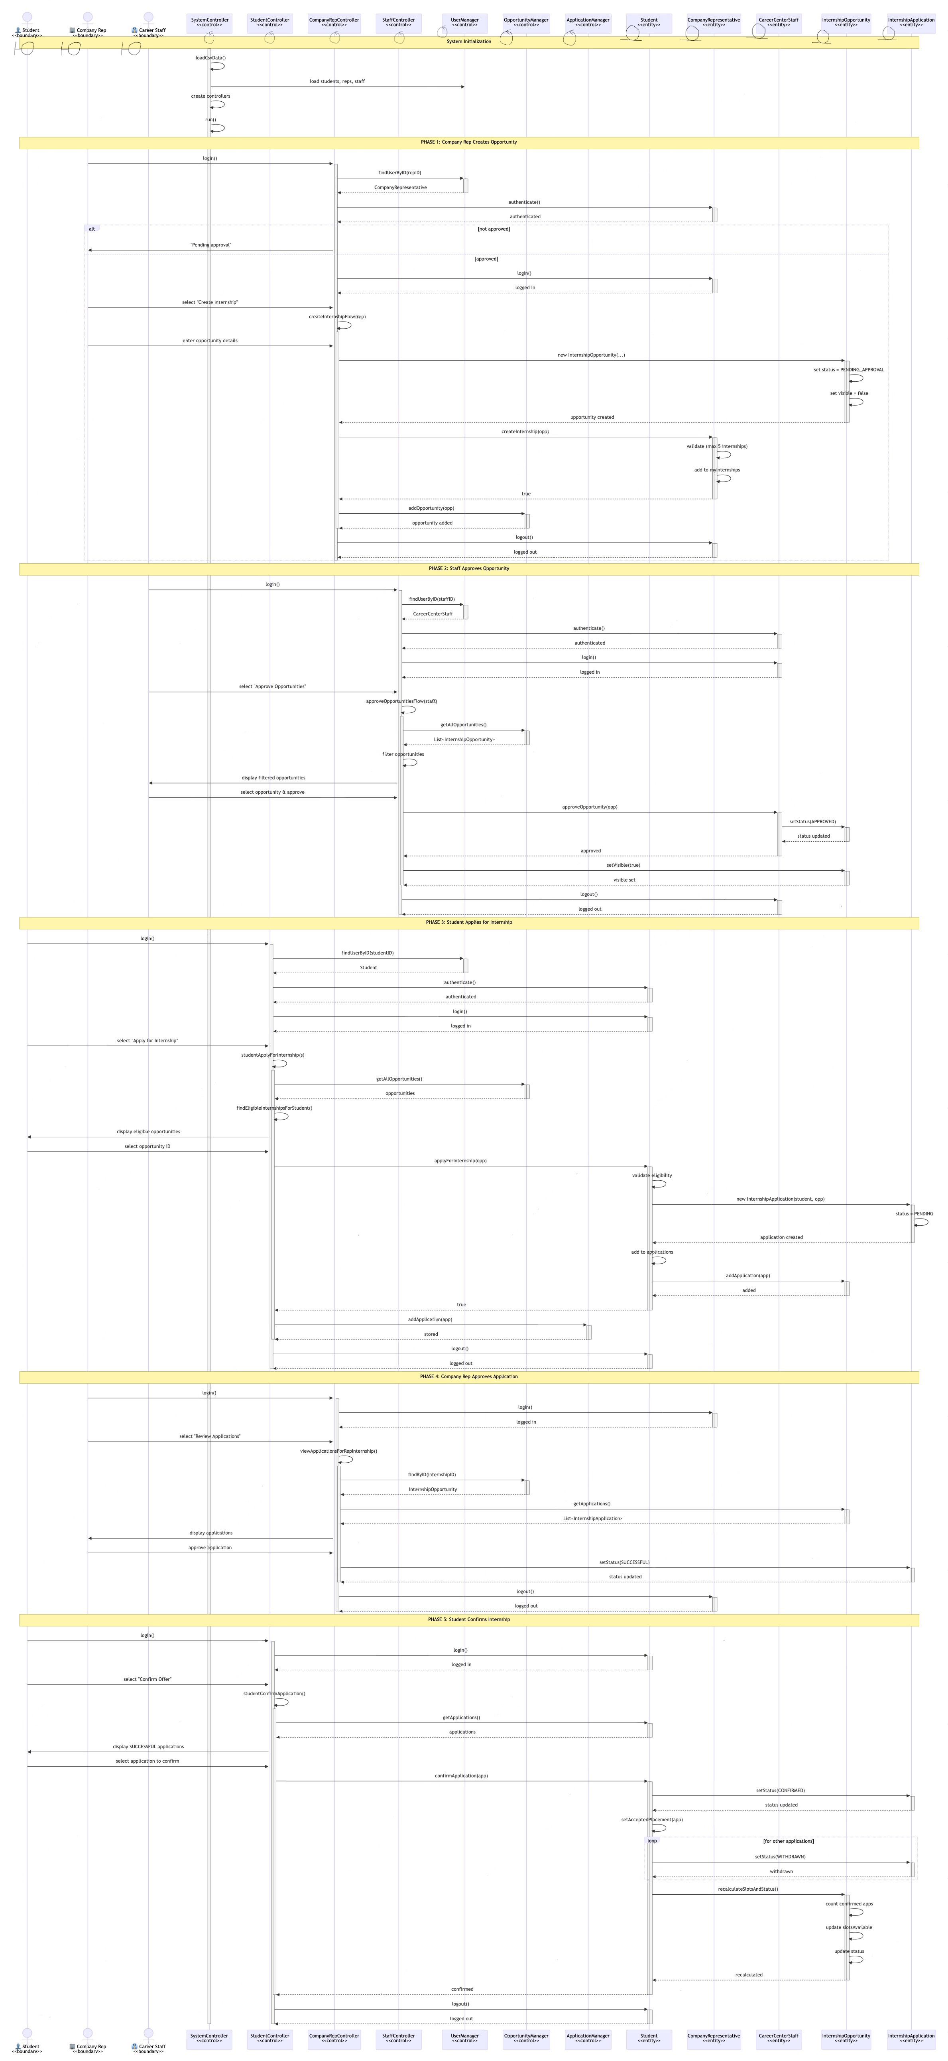
UML Class
For clearer UML Class diagram, please open the jpg file directly.
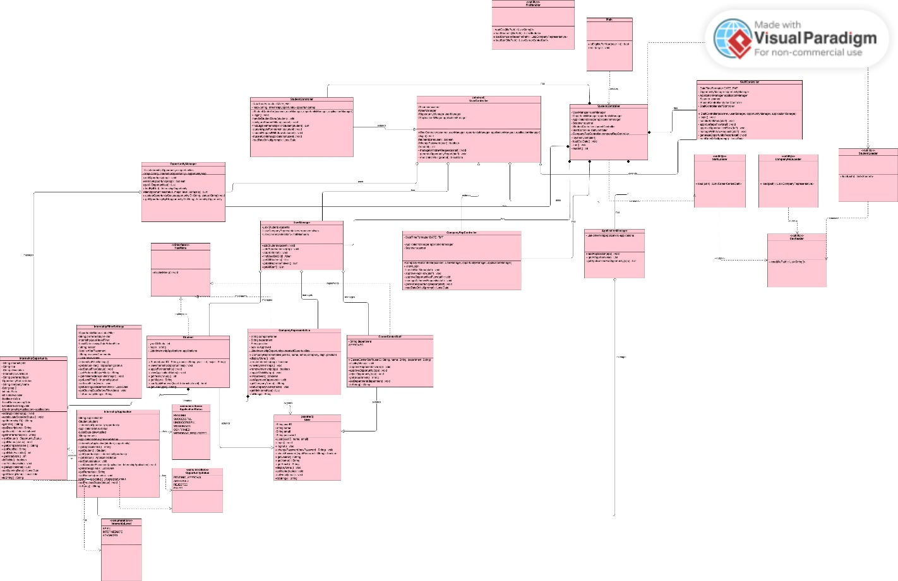
5) Testing
Kindly refer to the Test case folder to view image of each test case demonstrated.
No. | Test Cases | Expected Behaviour/ Output | Failure Indicator
TC01 | Valid User Login | When a valid userID exists in UserManager and the correct password is entered the user logs in and sees the correct role menu. | User cannot log in despite correct ID and password or sees the wrong role menu after login.
TC02 | Invalid User ID | If the entered ID is not found, the system prints “Invalid <role> ID.” and does not prompt for password or show a dashboard. | System proceeds to password prompt or logs in a user even though the ID does not exist.
TC03 | Incorrect Password | When the wrong password is entered, checkPassword fails and login is denied with “Login failed.” | User is able to access their menu with an incorrect password, or no meaningful error message is shown.
TC04 | Password Change Functionality | After entering the correct current password, updates the stored password and subsequent logins require the new password only. | Old password still works, new password does not work, or system accepts an empty/newline password despite validation.
TC05 | Company Representative Account Creation & Approval | New company representatives can register and cannot log in until a Career Staff approves. | Unapproved reps can proceed to password check or access the rep menu.
TC06 | Company Representative Login Blocked Before Approval | If account is not approved, should print the “pending approval” message and return to the menu without authenticating. | Unapproved reps can proceed to password check or access the rep menu.
TC07 | Internship Opportunity Visibility & Toggle Internship Visibility | Students can only see opportunities where isVisible() == true and status approved by staff, preferredMajor matches student’s major, and canApplyForLevel(level) is true. | Students see opportunities that are rejected and not visible to them.
TC08 | Student Application Eligibility Rules | Student.applyForInternship() only succeeds when: opportunity is visible and APPROVED, major matches, level eligibility is met, and the student has < 3 PENDING applications and has not already applied (non-withdrawn) to the same opportunity. | Student can apply to hidden, rejected, wrong-major, wrong-level opportunities; can exceed 3 PENDING applications; or can reapply to the same opportunity without having withdrawn.
TC09 | Viewing Application Status (Student) | Student.viewApplicationStatus() always lists all applications with their current ApplicationStatus, including those whose opportunities have later become invisible or filled. | Applications become inaccessible or disappear when visibility is toggled off or the opportunity changes state
TC10 | Company Representative – View Applications for Own Opportunity | Lists only applications for the selected opportunity that belongs to the logged-in rep | Rep can view applications for opportunities owned by other reps, or the system does not show applications for their own postings.
TC11 | Company Representative – Approve Application | When a rep approves an application via the menu, if the application status is PENDING, it is set to SUCCESSFUL and optional remarks are stored. | Application remains PENDING, remarks are not stored, or status changes for an application that should not be editable (e.g., WITHDRAWN or WITHDRAW_REQUESTED).
TC12 | Company Representative – Reject Application | When a rep rejects an application, status will be set to unsuccessful, is called and remarks (if any) are saved. | Status does not change correctly; rejected applications still show as PENDING or SUCCESSFUL.
TC13 | Rep Cannot Approve/Reject Withdrawn or Withdrawal-Pending Applications | If the selected application has status WITHDRAWN or WITHDRAW_REQUESTED, the system should display a message and skip approval/rejection options. | Rep is able to change the status of WITHDRAWN or WITHDRAW_REQUESTED applications to SUCCESSFUL or UNSUCCESSFUL.
TC14 | Student – Request Withdrawal of Application | Only allows withdrawal requests for applications in PENDING, SUCCESSFUL, or CONFIRMED states. New Status will be set to WITHDRAW_REQUESTED. | Student can request withdrawal for already WITHDRAWN applications, or status does not change to WITHDRAW_REQUESTED after a valid request.
TC15 | Staff – Manage Withdrawal Requests | Lists all WITHDRAW_REQUESTED applications from ApplicationManager. When staff approves, application status becomes WITHDRAWN, and if it was the student’s acceptedPlacement, Student.acceptedPlacement is cleared. | WITHDRAW_REQUESTED applications do not appear, status remains unchanged after staff approval, or acceptedPlacement is not cleared.
TC16 | Student – Confirm Internship Offer & Single Confirmed Placement per Student | Allows confirmation only for applications with status SUCCESSFUL. Student.confirmApplication() sets status to CONFIRMED, updates acceptedPlacement, and automatically sets all other PENDING/SUCCESSFUL/WITHDRAW_REQUESTED applications for that student to WITHDRAWN. | Student can confirm a non-SUCCESSFUL application, confirm more than one opportunity, or other active applications remain non-withdrawn after confirmation.
TC17 | Opportunity Filled Status Based on Confirmed Placements | After each CONFIRMED application, the system recomputes the number of confirmed applications for that InternshipOpportunity. When this reaches slotsAvailable, the opportunity’s status becomes FILLED and it should no longer be available for new applications. | Status becomes FILLED too early (e.g., on PENDING/SUCCESSFUL only) or never changes despite having as many CONFIRMED applications as slots.
TC18 | Rep – Create Internship with Constraints | Company Rep allow posting only maximum of 5 internships. New opportunities start with PENDING_APPROVAL and visible = false. | Reps bypass the “max 5” rule; status or visibility are not correctly initialised.
TC19 | Rep – Edit/Delete Only Pending Opportunities | Edits and deletions are only allowed when opp.getStatus() == PENDING_APPROVAL. After editing, the old opportunity is removed and a new one with the same ID is created. | Reps can edit or delete opportunities after they are APPROVED, REJECTED, or FILLED; edited opportunities are not properly re-attached to both rep and OpportunityManager.
TC20 | Staff – Approve/Reject Internship Opportunities | staff to set APPROVED or REJECTED on an opportunity. Approving also sets visible = true, making it appear in student listings if other filters match. | Status does not change, or approved opportunities remain invisible to students despite visible = true.
TC21 | Reporting – Generate & Filter Internship Opportunities | When the report feature is executed, the system correctly filters opportunities by status, level, preferred major, and company name, and prints accurate summaries. | Report lists opportunities that do not match the chosen filters, omits expected ones, or shows incorrect counts/fields.
TC22 | User Filters Internship Opportunities | All user types (Student, Company Rep, Staff) can apply filters—such as Status, Preferred Major, Internship Level, Closing Date (if implemented)—when viewing internship opportunities. | Filters do not work (incorrect or unexpected listings) or users see internships that do not match filter criteria.

6) Reflection and Challenges
In the early stages of the project, we built most of the system before learning SOLID principles, which resulted in major design issues. Our original SystemController became a 1,000-line “god class” handling login, menus, CSV loading, and business logic. It was messy, hard to debug, tightly coupled, and violated SRP and OCP, causing frequent breakages with small changes.
After properly understanding SOLID, we refactored the entire system. We split responsibilities into StudentController, StaffController, and CompanyRepController, moved data handling into UserManager and ApplicationManager, introduced an abstract UserController to avoid duplicated logic, and separated CSV loading into dedicated loader classes. This refactoring showed us how much harder it is to fix poor structure compared to planning it early.
Applying OOD concepts like composition, abstraction, and polymorphism was challenging. Passing shared dependencies (UserManager, OpportunityManager) without increasing coupling required careful design, and new features like stream filtering, withdrawal workflows, and per-student filters increased complexity and added many edge cases.
Teamwork was another difficulty. Coding simultaneously caused merge conflicts and overwritten files, so we switched to a divide-and-conquer workflow where some members coded while others updated UML diagrams and documentation. UML diagrams frequently fell out of sync with the code, teaching us that they must be updated continuously, not just at the end.
If we could redo the project, we would refine the class diagram earlier, maintain documentation consistently, avoid another god class, use Git branches more effectively, and start testing earlier.
Overall, the project taught us that OOD is practical, not theoretical. Clean design, modular classes, and separation of concerns are essential in larger systems. We learned the value of planning architecture early, collaborating properly, and keeping the design aligned as the system evolves.

Annex: Declaration of Original Work for SC2002 Assignment
We hereby declare that the attached group assignment has been researched, undertaken, completed, and submitted as a collective effort by the group members listed below.

We have honored the principles of academic integrity and have upheld Student Code of Academic Conduct in the completion of this work.

We understand that if plagiarism is found in the assignment, then lower marks or no marks will be awarded for the assessed work. In addition, disciplinary actions may be taken.

Name | Course | Lab Group | Signature / Date
Isaac Lim Yu Heng | SC2002 | SBAC1 | 
Jonah Choke Ming Kai | SC2002 | SBAC1 | 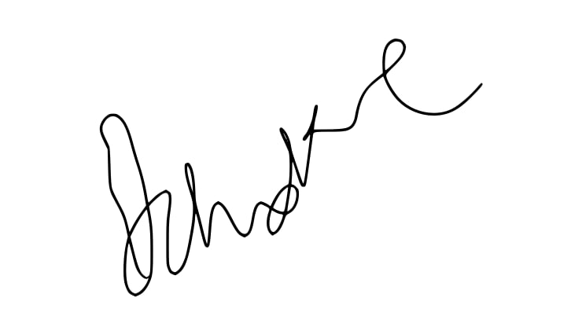
Kylie Pang Kai Li | SC2002 | SBAC1
Maureen Kai Shu Yuan | SC2002 | SBAC1 | 
Shaikh Aliyy Uraidhy Bin Shaikh Mohamed Reza Mattar | SC2002 | SBAC1 | 

